IPSI Case Study Summary Sheet

Please submit this form along with your case study. We ask that you keep your responses here as concise as possible. This information will be posted on the IPSI website unless otherwise requested. Please inform the IPSI Secretariat if there are any responses you would not like made public.

Basic Information
Title of case study (should be concise and within approximately 25 words)
Linking forest conservation with socio-economic development, Ugalingu Clan, Sogeram Valley, Papua New Guinea
Submitting IPSI member organization(s)
People, Resources and Conservation Foundation (PRCF)
Other contributing organization(s) (IPSI members and/or non-members)
Foundation for People and Community Development
Author(s) and affiliation(s)
Henry Scheyvens
PES and Policy Advisor,
People and Resources Conservation Foundation (PRCF)
Format of case study (manuscript or audiovisual) | Audiovisual (video) | Language | English
Keywords (3-5 key concepts included in the case study)
Sustainable agriculture, forest conservation, community-led development
Date of submission (or update, if this is an update of an existing case study) |  | 19 Dec. 2024
Web link (of the case study or lead organization if available for more information) | https://vimeo.com/1013346213?share=copy#t=0

Geographical Information
Country (where site(s) or activities described in the case study are located – can be multiple, or even “global”)
Papua New Guinea
Location(s) (within the country or countries – leave blank if specific location(s) cannot be identified)
Central Hills, Sogeram Valley, Madang Province
Longitude/latitude or Google Maps link (if location is identified)
145.188287° -5.255733°
Ecosystem(s) (please place an “x” in all appropriate boxes)
Forest | X | Grassland |  | Agricultural | X | In-land water |  | Coastal
Dryland |  | Mountain |  | Urban/peri-urban |  | Other (Please specify)
Socioeconomic and environmental characteristics of the area (within 50 words)
(Extended information provided to support the description given in the video)
Ugalingu are but one of many clans in Papua New Guinea located within logging concessions. The clan consists of less than 200 people and it holds about 4,000 ha of land under customary tenure within the Middle Ramu Block 1 Forest Management Area (FMA). The home base of the Ugalingu clan is Koromosarik Village, which has a population of about 1,000 people. Ugalingu customary land lies within the Gama Rural Local Level Government, which has a population density of only 5.6 people per km2. However, this area is experiencing rapid population growth, expanding on average by 4.3%/year from 2000 to 2011 (1).
Ugalingu customary land lies in a geographical zone known as the Central Hills. The Central Hills comprise about 3,400 sq km and form a divide between the Ramu River and the Sogeram River. They consist of closely dissected steep-sided hiIls and short ridges, and are traversed by many large tributaries of these two large rivers
The forests that the project aims to conserve are remnants of largely untouched, pristine tropical rainforest. The forest composition and structure are well maintained and intact, and the forest holds rich flora and fauna diversity. The project zone lies in the Northern New Guinea lowland rain and freshwater swamp forests ecoregion. Under PNG’s Forest Inventory Mapping (FIM) system, the forest in this zone has been mapped as Low Altitude Forest in Uplands Below 1,000 m.
Amongst the social groups in rural communities in Madang, church groups are prevalent. The major religions in the province include Roman Catholic, Seventh Day Adventist, United Church, Evangelical Lutheran, Pentecostal, etc. There are also undocumented cults. The mixing of religious and traditional spiritual beliefs is common. Customs that are upheld include the husband and wife living in separate huts, and a separate but being made available for visitors. Girls are expected to marry men with land.
Usino-Bundi, the district in which the project zone lies, has been ranked amongst the least developed and most disadvantaged districts in PNG, despite having two of the biggest revenue earners, Ramu Agri Industry Ltd and Ramu Nickel/Cobalt mine. About 35% of Madang’s population experiences moderate to severe food insecurity, only about 40% of the population have access to an improved source of drinking water (i.e. not drinking from a stream or other natural source), and roughly only 27% have access to an improved sanitation facility (i.e. flush toilet, pit latrine with slab, compost toilet, etc.) (NSO-ICF, 2019).
References
1. https://www.citypopulation.de/en/papuanewguinea/admin/usino_bundi/PG130619__gama_rural/
2. National Statistical Office (NSO) [Papua New Guinea] and ICF. 2019. Papua New Guinea Demographic and
Health Survey 2016-18. Port Moresby, Papua New Guinea, and Rockville, Maryland, USA: NSO and ICF.
Description of human-nature interactions in the area (land-use, traditional resource management practices etc. – within 50 words)
(Extended information provided to support the description given in the video)
The livelihoods of the Ugalingu clan are largely subsistence based and cash flow within the clan is very small. Traditional shifting agriculture provides the primary means of subsistence and is supplemented by hunting, fishing and gathering from the wild. The food on the table primarily comes from shifting agriculture. Sweet potato, taro, cassava, pineapple, papaya, corn, yam and green beans are grown in the subsistence gardens. Coconut, betel nut and sago are also cultivated. Fish are caught in Sogeram River.

The forest provides materials for buildings and tools, medicines and cultural practices, as well as food. Ugalingu forest also holds sites of forest dwelling spirits. These culturally significant sites include Kudupnge, Karukatamda, Kuvingkakme, Uyangikatam and Yambagesala.

In addition to traditional shifting agriculture, some households have permanent cacao plots, but will only maintain and harvest these for sale when the market offers a good price. Some households have a small number of livestock, especially chickens and pigs, but these mostly are kept for local consumption, rather than for sale. Only a few people are able to secure wage employment.

The system of shifting agriculture used by Ugalingu is practiced over a wide area, from the steep lands of the Adelbert mountains to the almost flat Ramu floodplain. The preparation of land, planting, maintenance and harvesting is largely a family affair, but inputs and produce are shared between families when the need arises.
Shifting agriculture starts with the clearing and burning of tall woody regrowth more than 15 years old. Clearing usually occurs from June to August and planting from July to December, each year. The period January-March can be a time of relative food shortage.

In making a new garden plot in the forest the undergrowth is first cleared, then most of the tall trees are felled by axe and the resulting debris is left to dry out. After firing, tubers, cuttings and seed are planted without any further preparation of the soil by means of a pointed dibble stick into any bare patch between the fallen logs which still litter the plot. Little or no weeding is done and after the initial crop the plot is abandoned to weed grasses, hardy ferns, wild ginger and other weeds. Only one planting is made before fallowing. After a number of cultivation-fallow cycles within a restricted area, another area of older, taller woody regrowth is selected. The more intensive cultivation-fallow cycle is begun here and the previously used area left to a long fallow.

Contents
Note: The following fields are used for information about activities described in the case study or the production of the case study itself, and contents may vary depending on the nature of the case study. For example, a case study about on-the-ground activities may include the rationale, objectives etc. for the activities; a case study about a SEPLS-related policy may describe the policymaking process; or a case study describing a SEPLS may address particular practices used there. Please make an effort to fill as many fields as possible.
Status (“ongoing” or “completed”) | Ongoing | Period (MM/YY to MM/YY) | 01 August 2022 – ongoing
Rationale (why activities or policies described, or information shared in the case study are needed – within 50 words)
(Extended information provided to support the description given in the video)
PNG is one of the few countries in the world where customary ownership of the land that originates in a tribal past is recognized by the national Constitution. Ninety-seven per cent of the land in PNG is held under systems of customary tenure, involving clans or kinship groups rather than individuals. Customary rights recognized by the Constitution include rights to all natural resources, with the exception of minerals, petroleum, water, and genetic resources.

While almost all natural forests in the country are owned under customary arrangements within local communities, unlike in the neighboring country of Indonesia, there is no national programme supporting community-based forest management. Rather than building local capacities for forest management, PNG’s land and forest development policies center on transferring forest and land rights away from customary local groups to outside developers for large-scale forestry, agricultural and mining projects. This development paradigm has provided some local benefits, e.g. improved access to markets and government services through the construction of logging roads and temporary employment in logging operations, but has also resulted in significant environmental and social harm.

Ugalingu forest holds high conservation values and provides important ecosystem services, but is facing serious threat from logging and agricultural expansion. The underlying drivers of these local threats include rapid local population growth, a lack of local capacities, resources and opportunities to develop alternative livelihoods, and weak community institutions to ensure sustainable land use.
A concern with industrial-scale agriculture and forestry projects in PNG is that they diminish the self-reliance of local communities by contributing to a hand-out mentality. In these projects, the customary landowners receive large sums of money in the form of royalties for the use of their land and resource, much of which is spent quickly for little long-term gain. Even though some of these projects may be labelled “joint ventures,” generally the communities have no roles in them. Their capacities and institutions are not being built by these projects; rather, their social fabric breaks down due to lack of informed decision-making over the transfer of land and resource rights and jealousies over benefit distribution. When the logging is completed, the customary landowners find themselves frustrated as the flow of royalties stops and the logging roads fall into disrepair and become unpassable. They are at a loss of what they should or can do to advance the interests of their communities.

The Middle Ramu Block 1 concession where Ugalingu customary land is located was purchased on 24 June 2004 and runs for 50 years through to 2054. It has a gross area of 159,000 ha. While most clans in concession agreed to their forests being logged, Ugalingu did not. Umari Bagusa is the clan leader and under customary norms makes the major decisions over land use. He continues to resist approaches from the logging company, having seen the environmental damage wrought by the logging in surrounding areas. The project supports the vision for the community of the current traditional clan leader, Umari Bagusa, of having a pristine forest rich in biodiversity while simultaneously progressing towards creating a better life for the clan.
Objectives (goals of activities or policies described, or of producing the case study – within 50 words)
(Extended information provided to support the description given in the video)
The overall objective of the project is to strengthen community institutions and capacities and provide incentives for community-based nature conservation linked with economic uplift of the Ugalingu people. The project also intends to increase this support to other communities in the landscape who are protecting their forest from logging and to link these efforts with initiatives in the nearby Wanang Conservation Area. The project’s aims are to:
- Build community understanding, capacities and institutions to tackle forest threats and develop and implement conservation strategies;
- Reduce forest pressure, improve food security and promote economic uplift by supporting a transition from shifting agriculture to permanent, climate-resilient agriculture and the development of community-based enterprises;
- Secure long-term financing for forest conservation and community development in the form of payment for ecosystem services (PES).
Activities and/or practices employed (within 50 words)
(Extended information provided to support the description given in the video)

The background to this project is a series of earlier FPCD projects supporting Ugalingu in collaboration with funders and research institutes. Under one of its main projects, FPCD was able to acquire a Forest Stewardship Council (FSC) Group Certificate and brought Ugalingu under its FSC-certified Indigenous Community Forestry scheme. Support was provided to Ugalingu to develop a forest management plan that allowed Ugalingu to selectively and sustainably harvest a small number of trees from its forest each year, to process the logs into sawn wood, and to sell the sawn wood to international buyers. FPCD was unable to maintain the certification however, and this project ceased. FPCD later provided support to Ugalingu to promote the use of fuel-efficient cook stoves and to build climate resilience.

In another earlier project, FPCD joined Japan’s Institute for Global Environmental Strategies (IGES) in training Ugalingu on forest mensuration. Together, FPCD, IGES and Ugalingu established and measured 12 permanent sample plots in Ugalingu forest, and used the data to estimate average per hectare carbon stocks.

Building on these earlier experiences, the People, Resources and Conservation Foundation (PRCF) agreed with FPCD to work on the design of a project to secure long-term PES financing for nature conservation and community development on Ugalingu customary land, with potential to include other communities in the project design. A community workshop with Ugalingu was conducted in October 2022 to discuss the idea of such a project and to discuss project activities.

As developing a PES project can take several years, it was agreed that at the same time that PRCF and FPCD were developing the project design, they would also provide support to Ugalingu to promote sustainable agriculture incorporating eco-agricultural concepts and methods. The video prepared for this case study provides footage of some of this support to promote sustainable agriculture. At the time of writing, 4 demonstration plots have been established and are being maintained by Ugalingu farmers, and, with support from FPCD, Ugalingu is providing monthly monitoring on the performance of these plots.

The activities outlined in the concept note for the proposed PES project include:
- Establishment of community-based forest and land-use management committees (CFMLUCs);
- Building the capacities of and resourcing the CFMLUCs;
- Providing technical inputs and facilitation to support the CFMLUCs in developing forest and land-use management plans;
- Establishing signage on forest boundaries to identify the areas of conservation forest;
- Providing training to and resourcing the CFMLUCs to conduct regular forest patrols;
- Supporting a transition from shifting agriculture to sustainable permanent agriculture; and
- Providing investments in community-based businesses and areas of social development prioritized by community members.
In addition to Ugalingu, other clans in the concession that are protecting their forest from logging and are interested in forest conservation would also be eligible for the PES project.
Monitoring methodology (e.g. GIS-based monitoring, citizen science, Resilience Indicators in SEPLS, survey - within 40 words)
(Extended information provided to support the description given in the video)
Monitoring is currently restricted to the only activity that is currently being implemented under the project with Ugalingu, i.e. support for sustainable agriculture. Monitoring of the demonstration plots is conducted monthly by Ugalingu members, with support from FPCD. The monitoring process includes visits to each demonstration plot and a key farmers’ meeting to discuss progress and challenges. The monitoring covers inputs and crop performance.

The PES project is being designed using an international sustainability standard. Monitoring parameters, frequency and methods are determined by the standard and include use of remote sensing and GIS, ground-based surveys of biodiversity and ecosystem services, and monitoring of project impacts on community well-being using household surveys and focus group discussions.
Results (within 50 words)
The project is at an early stage of development and the results are limited to the support to promote sustainable agriculture. The agricultural demonstration plots have only recently been developed and it is too early to draw conclusions on their performance.
Lessons learned (factors in success or failure, challenges and opportunities – within 40 words)
(Extended information provided to support the description given in the video)
The lessons learned from engagement to date with Ugalingu include:
- Before the start of any support project to communities, there must be a clear understanding of the different interest groups that exist within each community and the relationships between them. Without such understanding, there is a risk that the project may not be supported by some groups, leading to disagreements over project objectives and activities. An adaptive management approach should be adopted, enabling any necessary adjustments in community engagement processes to deal with issues that arise within the community over the project.
- Continuous engagement with the community is necessary to build their trust in development partners. Long periods with little contact are discouraging for the community and this can make re-engagement difficult.
- All project activities should be designed with the aim of building community institutions and capacities. If a project mostly only provides resources and material inputs, there is a risk that community members will view the development partner, not as a partner but as a patron or “gift-giver.” Further requests for “gifts” can be expected and community self-reliance will be undermined.

Funding (any relevant information about funding of activities or projects described in the case study)
Funding for the community workshop and for the initial support to promote sustainable agriculture is provided by PRCF. Proposals are being submitted to various funders to extend the support activities to Ugalingu and other eligible communities, as well as to complete the initial design of a PES project.

Contributions to Global Agendas

CBD Kunming-Montreal Global Biodiversity Framework (https://www.cbd.int/gbf/targets/)
Please place an "x" under a number to rate how much this case study contributes to each CBD Target.
Note 1: The number scale goes from 1, the lowest rating, to 5, the highest rating. N/A indicates “not applicable”.
Note 2: Please only mark those to which the case study has or will actually contribute, not those to which it could potentially contribute in the future.

Target |  | Description | Contribution
 |  |  | 1 | 2 | 3 | 4 | 5 | N/A
1. Reducing threats to biodiversity | 1 | Ensure that all areas are under participatory, integrated and biodiversity inclusive spatial planning and/or effective management processes addressing land- and sea-use change, to bring the loss of areas of high biodiversity importance, including ecosystems of high ecological integrity, close to zero by 2030, while respecting the rights of indigenous peoples and local communities. |  |  |  |  | X
 | 2 | Ensure that by 2030 at least 30 per cent of areas of degraded terrestrial, inland water, and marine and coastal ecosystems are under effective restoration, in order to enhance biodiversity and ecosystem functions and services, ecological integrity and connectivity. |  | X
 | 3 | Ensure and enable that by 2030 at least 30 per cent of terrestrial and inland water areas, and of marine and coastal areas, especially areas of particular importance for biodiversity and ecosystem functions and services, are effectively conserved and managed through ecologically representative, well-connected and equitably governed systems of protected areas and other effective area-based conservation measures, recognizing indigenous and traditional territories, where applicable, and integrated into wider landscapes, seascapes and the ocean, while ensuring that any sustainable use, where appropriate in such areas, is fully consistent with conservation outcomes, recognizing and respecting the rights of indigenous peoples and local communities, including over their traditional territories. |  |  |  | X
 | 4 | Ensure urgent management actions to halt human induced extinction of known threatened species and for the recovery and conservation of species, in particular threatened species, to significantly reduce extinction risk, as well as to maintain and restore the genetic diversity within and between populations of native, wild and domesticated species to maintain their adaptive potential, including through in situ and ex situ conservation and sustainable management practices, and effectively manage human-wildlife interactions to minimize human-wildlife conflict for coexistence.
 | 5 | Ensure that the use, harvesting and trade of wild species is sustainable, safe and legal, preventing overexploitation, minimizing impacts on non-target species and ecosystems, and reducing the risk of pathogen spillover, applying the ecosystem approach, while respecting and protecting customary sustainable use by indigenous peoples and local communities.
 | 6 | Eliminate, minimize, reduce and or mitigate the impacts of invasive alien species on biodiversity and ecosystem services by identifying and managing pathways of the introduction of alien species, preventing the introduction and establishment of priority invasive alien species, reducing the rates of introduction and establishment of other known or potential invasive alien species by at least 50 per cent by 2030, and eradicating or controlling invasive alien species, especially in priority sites, such as islands.
 | 7 | Reduce pollution risks and the negative impact of pollution from all sources by 2030, to levels that are not harmful to biodiversity and ecosystem functions and services, considering cumulative effects, including: (a) by reducing excess nutrients lost to the environment by at least half, including through more efficient nutrient cycling and use; (b) by reducing the overall risk from pesticides and highly hazardous chemicals by at least 8half, including through integrated pest management, based on science, taking into account food security and livelihoods; and (c) by preventing, reducing, and working towards eliminating plastic pollution.
 | 8 | Minimize the impact of climate change and ocean acidification on biodiversity and increase its resilience through mitigation, adaptation, and disaster risk reduction actions, including through nature-based solution and/or ecosystem-based approaches, while minimizing negative and fostering positive impacts of climate action on biodiversity.
2. Meeting people’s needs through sustainable use and benefit-sharing | 9 | Ensure that the management and use of wild species are sustainable, thereby providing social, economic and environmental benefits for people, especially those in vulnerable situations and those most dependent on biodiversity, including through sustainable biodiversity-based activities, products and services that enhance biodiversity, and protecting and encouraging customary sustainable use by indigenous peoples and local communities. |  |  | X
 | 10 | Ensure that areas under agriculture, aquaculture, fisheries and forestry are managed sustainably, in particular through the sustainable use of biodiversity, including through a substantial increase of the application of biodiversity friendly practices, such as sustainable intensification, agroecological and other innovative approaches, contributing to the resilience and long-term efficiency and productivity of these production systems, and to food security, conserving and restoring biodiversity and maintaining nature’s contributions to people, including ecosystem functions and services. |  |  |  |  | X
 | 11 | Restore, maintain and enhance nature’s contributions to people, including ecosystem functions and services, such as the regulation of air, water and climate, soil health, pollination and reduction of disease risk, as well as protection from natural hazards and disasters, through nature-based solutions and/or ecosystem-based approaches for the benefit of all people and nature. |  |  |  |  | X
 | 12 | Significantly increase the area and quality, and connectivity of, access to, and benefits from green and blue spaces in urban and densely populated areas sustainably, by mainstreaming the conservation and sustainable use of biodiversity, and ensure biodiversity-inclusive urban planning, enhancing native biodiversity, ecological connectivity and integrity, and improving human health and well-being and connection to nature, and contributing to inclusive and sustainable urbanization and to the provision of ecosystem functions and services.
 | 13 | Take effective legal, policy, administrative and capacity-building measures at all levels, as appropriate, to ensure the fair and equitable sharing of benefits that arise from the utilization of genetic resources and from digital sequence information on genetic resources, as well as traditional knowledge associated with genetic resources, and facilitating appropriate access to genetic resources, and by 2030, facilitating a significant increase of the benefits shared, in accordance with applicable international access and benefit-sharing instruments.
3. Tools and solutions for implementation and mainstreaming | 14 | Ensure the full integration of biodiversity and its multiple values into policies, regulations, planning and development processes, poverty eradication strategies, strategic environmental assessments, environmental impact assessments and, as appropriate, national accounting, within and across all levels of government and across all sectors, in particular those with significant impacts on biodiversity, progressively aligning all relevant public and private activities, and fiscal and financial flows with the goals and targets of this framework.
 | 15 | Take legal, administrative or policy measures to encourage and enable business, and in particular to ensure that large and transnational companies and financial institutions:  (a) Regularly monitor, assess, and transparently disclose their risks, dependencies and impacts on biodiversity, including with requirements for all large as well as transnational companies and financial institutions along their operations, supply and value chains, and portfolios;  (b) Provide information needed to consumers to promote sustainable consumption patterns;  (c) Report on compliance with access and benefit-sharing regulations and measures, as applicable;  in order to progressively reduce negative impacts on biodiversity, increase positive impacts, reduce biodiversity-related risks to business and financial institutions, and promote actions to ensure sustainable patterns of production.
 | 16 | Ensure that people are encouraged and enabled to make sustainable consumption choices, including by establishing supportive policy, legislative or regulatory frameworks, improving education and access to relevant and accurate information and alternatives, and by 2030, reduce the global footprint of consumption in an equitable manner, including through halving global food waste, significantly reducing overconsumption and substantially reducing waste generation, in order for all people to live well in harmony with Mother Earth.
 | 17 | Establish, strengthen capacity for, and implement in all countries, biosafety measures as set out in Article 8(g) of the Convention on Biological Diversity and measures for the handling of biotechnology and distribution of its benefits as set out in Article 19 of the Convention.
 | 18 | Identify by 2025, and eliminate, phase out or reform incentives, including subsidies, harmful for biodiversity, in a proportionate, just, fair, effective and equitable way, while substantially and progressively reducing them by at least $500 billion per year by 2030, starting with the most harmful incentives, and scale up positive incentives for the conservation and sustainable use of biodiversity.
 | 19 | Substantially and progressively increase the level of financial resources from all sources, in an effective, timely and easily accessible manner, including domestic, international, public and private resources, in accordance with Article 20 of the Convention, to implement national biodiversity strategies and action plans, mobilizing at least $200 billion per year by 2030, including by:  (a) Increasing total biodiversity related international financial resources from developed countries, including official development assistance, and from countries that voluntarily assume obligations of developed country Parties, to developing countries, in particular the least developed countries and small island developing States, as well as countries with economies in transition, to at least $20 billion per year by 2025, and to at least $30 billion per year by 2030;  (b) Significantly increasing domestic resource mobilization, facilitated by the preparation and implementation of national biodiversity finance plans or similar instruments according to national needs, priorities and circumstances;  (c) Leveraging private finance, promoting blended finance, implementing strategies for raising new and additional resources, and encouraging the private sector to invest in biodiversity, including through impact funds and other instruments;  (d) Stimulating innovative schemes such as payment for ecosystem services, green bonds, biodiversity offsets and credits, and benefit-sharing mechanisms, with environmental and social safeguards;  (e) Optimizing co-benefits and synergies of finance targeting the biodiversity and climate crises;  (f) Enhancing the role of collective actions, including by indigenous peoples and local communities, Mother Earth centric actions[1] and non-market-based approaches including community based natural resource management and civil society cooperation and solidarity aimed at the conservation of biodiversity;  (g) Enhancing the effectiveness, efficiency and transparency of resource provision and use; |  |  |  |  | X
 | 20 | Strengthen capacity-building and development, access to and transfer of technology, and promote development of and access to innovation and technical and scientific cooperation, including through South‑South, North-South and triangular cooperation, to meet the needs for effective implementation, particularly in developing countries, fostering joint technology development and joint scientific research programmes for the conservation and sustainable use of biodiversity and strengthening scientific research and monitoring capacities, commensurate with the ambition of the goals and targets of the Framework. |  |  | X
 | 21 | Ensure that the best available data, information and knowledge are accessible to decision makers, practitioners and the public to guide effective and equitable governance, integrated and participatory management of biodiversity, and to strengthen communication, awareness-raising, education, monitoring, research and knowledge management and, also in this context, traditional knowledge, innovations, practices and technologies of indigenous peoples and local communities should only be accessed with their free, prior and informed consent,[2] in accordance with national legislation.
 | 22 | Ensure the full, equitable, inclusive, effective and gender-responsive representation and participation in decision-making, and access to justice and information related to biodiversity by indigenous peoples and local communities, respecting their cultures and their rights over lands, territories, resources, and traditional knowledge, as well as by women and girls, children and youth, and persons with disabilities and ensure the full protection of environmental human rights defenders. |  |  |  | X
 | 23 | Ensure gender equality in the implementation of the Framework through a gender-responsive approach, where all women and girls have equal opportunity and capacity to contribute to the three objectives of the Convention, including by recognizing their equal rights and access to land and natural resources and their full, equitable, meaningful and informed participation and leadership at all levels of action, engagement, policy and decision-making related to biodiversity. |  |  |  | X

UN Sustainable Development Goals (SDGs) (https://sustainabledevelopment.un.org/sdgs)
Please place an “x” in the “direct” or “indirect” boxes next to any of the UN Sustainable Development Goals to which the work described in this case study contributes as appropriate. Note: please mark only those that the case actually has made or is making a contribution, not those to which it could make a potential contribution in the future.
SDG | Description | Direct | Indirect
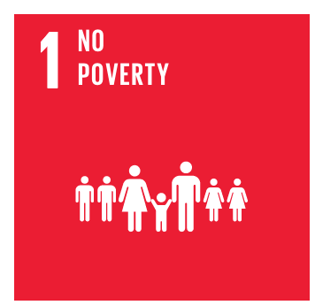 | End poverty in all its forms everywhere | X
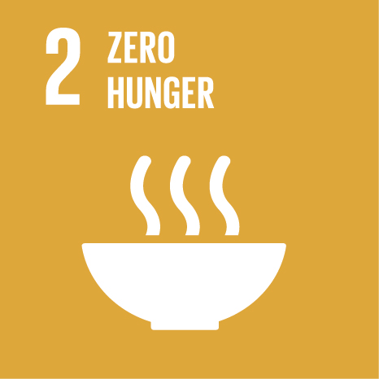 | End hunger, achieve food security and improved nutrition, and promote sustainable agriculture | X
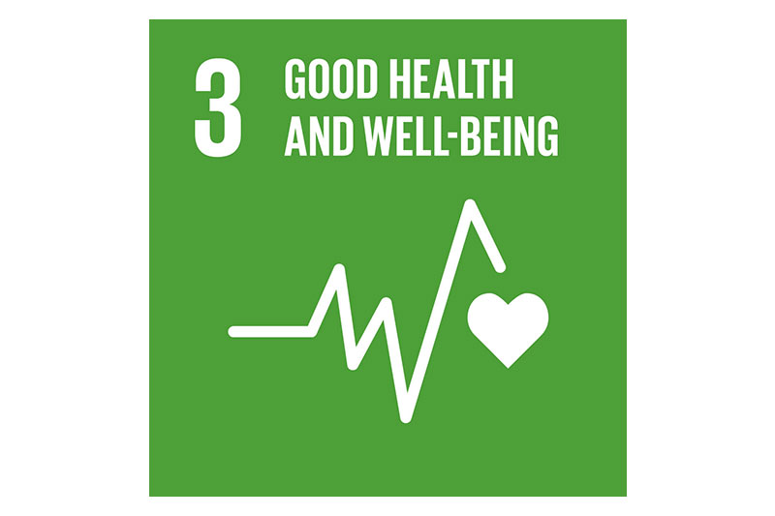 | Ensure healthy lives and promote wellbeing for all at all ages | X
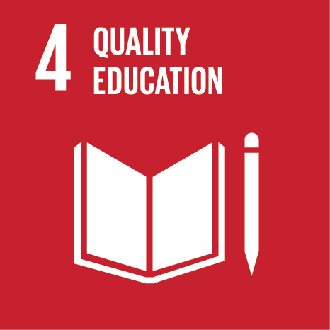 | Ensure inclusive and equitable quality education and promote lifelong learning opportunities for all |  | X
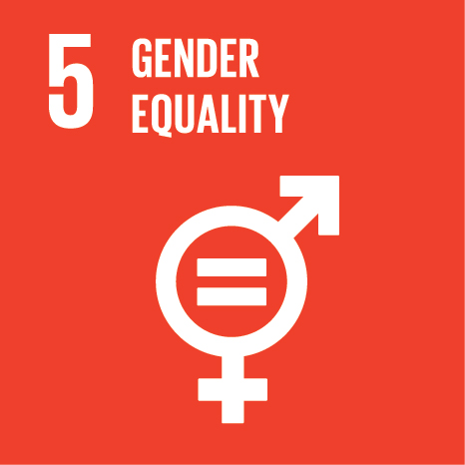 | Achieve gender equality and empower all women and girls |  | X
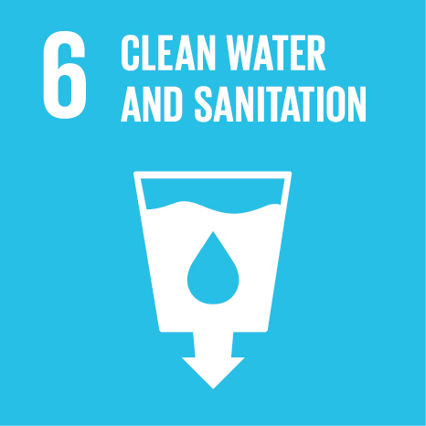 | Ensure availability and sustainable management of water and sanitation for all
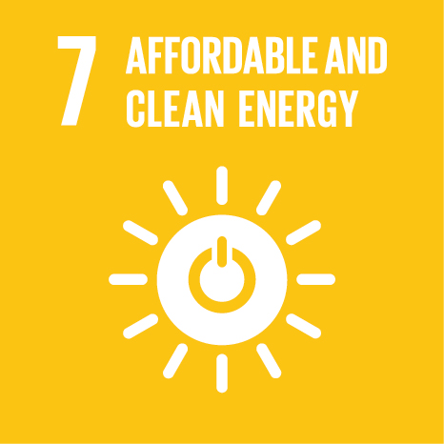 | Ensure access to affordable, reliable, sustainable and modern energy for all
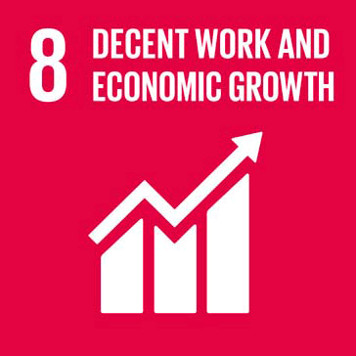 | Promote sustained, inclusive and sustainable economic growth, full and productive employment, and decent work for all |  | X
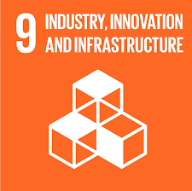 | Build resilient infrastructure, promote inclusive and sustainable industrialisation, and foster innovation
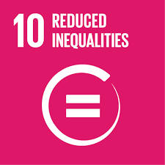 | Reduce inequality within and among countries |  | X
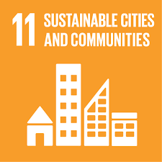 | Make cities and human settlements inclusive, safe, resilient and sustainable
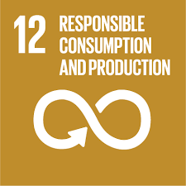 | Ensure sustainable consumption and production patterns
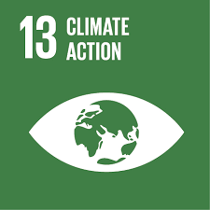 | Take urgent action to combat climate change and its impacts | X
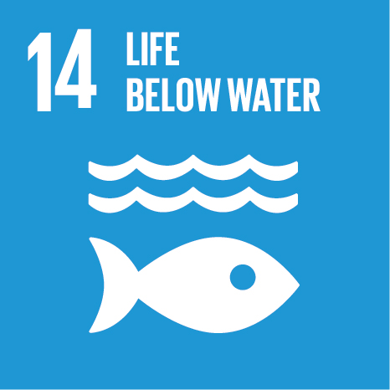 | Conserve and sustainably use the oceans, seas and marine resources for sustainable development
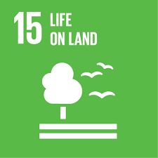 | Protect, restore and promote sustainable use of terrestrial ecosystems, sustainably manage forests, combat desertification and halt and reverse land degradation, and halt biodiversity loss | X
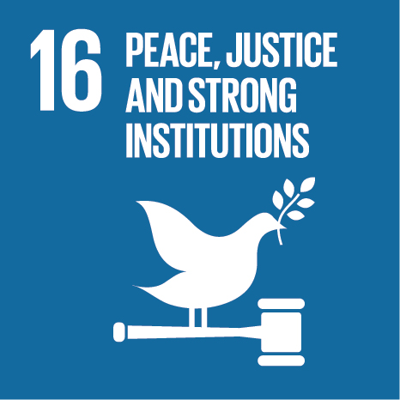 | Promote peaceful and inclusive societies for sustainable development, provide access to justice for all and build effective, accountable and inclusive institutions at all levels |  | X
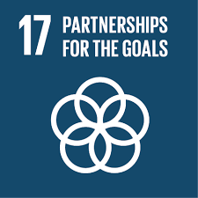 | Strengthen the means of implementation and revitalise the global partnership for sustainable development

