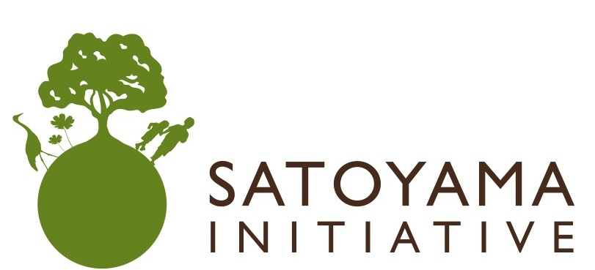
Invitation

The Strategic Plan for the Post-2010 Period and the Satoyama Initiative

Date & Time: | Monday, 24 May 2010, 13:15 – 14:45
Venue: | CR-3, UNEP, Nairobi, Kenya
Organisers: | Ministry of the Environment, Japan (MOEJ)  Ministry of Foreign Affairs, Japan (MOFAJ)  United Nations University Institute of Advanced Studies (UNU-IAS)
Co-organisers: | United Nations Development Programme (UNDP), United Nations Environment Programme (UNEP), Secretariat of the Convention on Biological Diversity (SCBD), World Agroforestry Centre (ICRAF), Bioversity International,
This side event discusses ways through which it could be possible to support and, as needed, revitalize the human-influenced natural environment (or socio-ecological production landscapes) that can provide human well-being while conserving biodiversity, and introduces the so-called Satoyama Initiative as a solution. This Initiative intends to support the Strategic Plan for the Post-2010 Period and promote sustainable use of natural resources in socio-ecological production landscape such as agricultural fields and secondary forests, and ultimately contribute to achieving the objectives of Convention on Biological Diversity. Mechanisms to support the initiative will also be described, including in particular the establishment of an international partnership that will be formally launched in October in Nagoya at COP-10 and possible schemes to support on-the-ground activities in line with the Satoyama Initiative.
Programme
13:15 – 13:25 Opening Remarks
Kazuaki Hoshino —Director, Biodiversity Policy Division, Nature Conservation Bureau, MOEJ
Ahmed Djoghlaf —Executive Secretary of the Convention on Biological Diversity
13:25-13:40 Japans Perspectives on the proposed Strategic Plan for the Post 2010
Masayoshi Mizuno—Director, Global Environment Division, International Cooperation Bureau, MOFAJ
13:40-13:55 Paris Declaration on the Satoyama Initiative -- The Initiative and what it intends to achieve
Somaly Chan — Director, International Convention and Biodiversity, Department of the Ministry of Environment, Cambodia
13:55 – 14:10 Proposal to launch an International Partnership to support implementation of the Initiative
Alphonse Kambu—Division of Environmental Law and Conventions(DELC), UNEP, on behalf of ICRAF, Bioversity International and UNEP
14:10 – 14:25 Proposed Financial Mechanism to Support Communities Advancing Socio-ecological Production Landscapes
Kazuaki Hoshino—MOEJ
14:25– 14:45 Q &A

Lunch will be provided!

