REPUBLIC OF NIGER


Brotherhood–Work –Progress
PRIME MINISTER’S CABINET
ENVIRONMENTAL NATIONAL COUNCIL FOR A SUSTAINABLE DEVELOPMENT
EXECUTIVE SECRETARIAT
Biological Diversity Division

The resilience of socio economic landscapes is restored in order to provide food security to the local communities and to enable them to coop with the changing climate in Niger.

Land restoration program
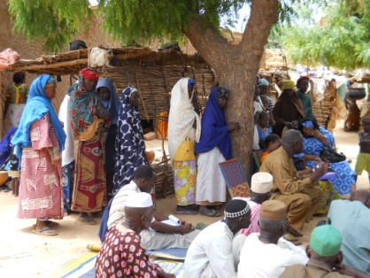 |  | 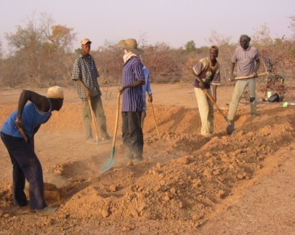 |  |  |  | 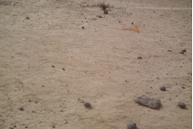  Arid Land!!!  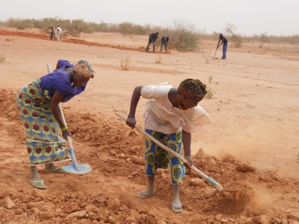
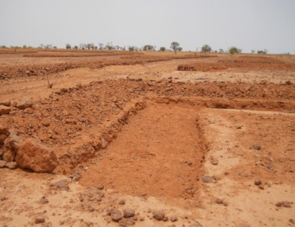 | 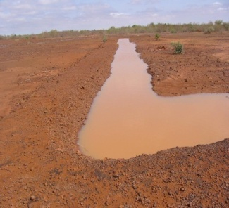 |  | 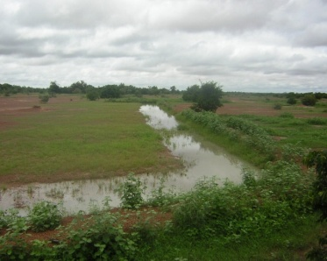  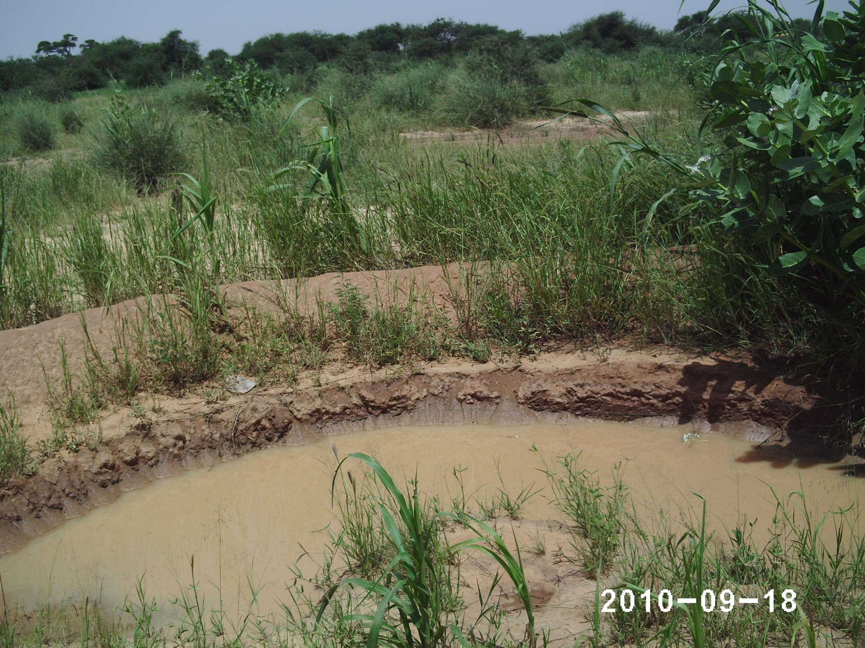

ARID LANDS BEING RESTORED AND ABLE TO SUSTAIN AND IMPROVE THE LIVELIHOODS OF THE LOCAL COMMUNITIES

Niger is a landlocked country, with an area of about 1,267,000 sq km; ¾ covered by the Sahara desert; Mean rainfall 300 to 800 mm/year; Temperature ranges between 0°c – 17°c in the Sahara desert while it ranges between 16°c – 45°c in the rest of the country. Due to climate change, the rainfall is sparsely distributed in time and space scale. These situations lead to loss of forest resources, farmlands and grasslands. Lands degradation has weaken the capacity of the local populations to coop with the changing climate. In order to face this situation, Niger republic developed a land restoration program. The aim of this program is to help the local communities develop locally adapted resilience methods in order to resist to harsh climatic conditions.
The approach is participatory and leads the following results:
- reduction of water run-off on the soils,
- increase water infiltration
- increase the production of biomass from 0 to 70%.
- improve in the farms yields (from 400kg/ha to about 1000 to 1200kg/ha).

Land area restored | Number of working days | socio-economic Impacts
4550 ha | 26640 | - Increase in the production of grasses for the livestock;  - Increase in lands productivity: more food production;  - Increase in the revenue of the households

SE-CNEDD , BP 10193 Niamey (Niger)
Fax : + 227 20722981 Tél. : + 227 20722559 Site WEB : ne.chm-cbd.net

